Lab - Configuring a Switch Management Address (Instructor Version)

**Instructor Note**: Red font color or Gray highlights indicate text that appears in the instructor copy only.

Topology

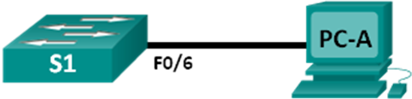

1. Addressing Table

|  |  |  |  |  |
| --- | --- | --- | --- | --- |
| Device | Interface | IP Address | Subnet Mask | Default Gateway |
| S1 | VLAN 1 | 192.168.1.2 | 255.255.255.0 | N/A |
| PC-A | NIC | 192.168.1.10 | 255.255.255.0 | N/A |

1. Objectives

Part 1: Configure a Basic Network Device

* Cable the network as shown in the topology.
* Configure basic switch settings including hostname, management address, and Telnet access.
* Configure an IP address on the PC.

Part 2: Verify and Test Network Connectivity

* Display device configuration.
* Test end-to-end connectivity with ping.
* Test remote management capability with Telnet.
* Save the switch running configuration file.

1. Background / Scenario

Cisco switches have a special interface, known as a switch virtual interface (SVI). The SVI can be configured with an IP address, commonly referred to as the management address that is used for remote access to the switch to display or configure settings.

In this lab, you will build a simple network using Ethernet LAN cabling and access a Cisco switch using the console and remote access methods. You will configure basic switch settings and IP addressing, and demonstrate the use of a management IP address for remote switch management. The topology consists of one switch and one host using only Ethernet and console ports.

**Note**: The switches used are Cisco Catalyst 2960s with Cisco IOS Release 15.0(2) (lanbasek9 image). Other switches and Cisco IOS versions can be used. Depending on the model and Cisco IOS version, the available commands and output produced might vary from what is shown in the labs.

**Note**: Make sure that the switch has been erased and has no startup configuration. If you are unsure, contact your instructor.

**Instructor Note**: Refer to the Instructor Lab Manual for the procedures to initialize and reload devices.

1. Required Resources

* 1 Switch (Cisco 2960 with Cisco IOS Release 15.0(2) lanbasek9 image or comparable)
* 1 PC (Windows 7, Vista, or XP with terminal emulation program, such as Tera Term)
* Console cables to configure the Cisco IOS devices via the console ports
* Ethernet cables as shown in the topology

1. Configure a Basic Network Device

In Part 1, you will set up the network and configure basic settings, such as hostnames, interface IP addresses, and passwords.

* 1. Cable the network.

1. Cable the network as shown in the topology.
2. Establish a console connection to the switch from PC-A.
   1. Configure basic switch settings.

In this step, you will configure basic switch settings, such as hostname and configuring an IP address for the SVI. Assigning an IP address on the switch is only the first step. As the network administrator, you must specify how the switch will be managed. Telnet and Secure Shell (SSH) are two of the most common management methods; however, Telnet is a very insecure protocol. All information flowing between the two devices is sent in plain text. Passwords and other sensitive information can be easily looked at if captured by a packet sniffer.

1. Assuming the switch had no configuration file stored in nonvolatile random-access memory (NVRAM), you will be at the user EXEC mode prompt on the switch with a prompt of Switch>. Enter privileged EXEC mode.

Switch> **enable**

Switch#

1. Verify a clean configuration file with the **show running-config** privileged EXEC command. If a configuration file was previously saved, it will have to be removed. Depending on the switch model and IOS version, your configuration may look slightly different. However, there should be no configured passwords or IP address set. If your switch does not have a default configuration, ask your instructor for help.
2. Enter global configuration mode and assign the switch hostname.

Switch# **configure terminal**

Switch(config)# **hostname S1**

S1(config)#

1. Configure the switch password access.

S1(config)# **enable secret class**

S1(config)#

1. Prevent unwanted Domain Name System (DNS) lookups.

S1(config)# **no ip domain-lookup**

S1(config)#

1. Configure a login message-of-the-day (MOTD) banner.

S1(config)# **banner motd #**

Enter Text message. End with the character ‘#’.

**Unauthorized access is strictly prohibited. #**

1. Verify your access setting by moving between modes.

S1(config)# **exit**

S1#

S1# **exit**

Unauthorized access is strictly prohibited.

S1>

What shortcut keys are used to go directly from global configuration mode to privileged EXEC mode?

____________________________________________________________________________________

Ctrl+Z

1. Return to privileged EXEC mode from user EXEC mode.

S1> **enable**

Password: **class**

S1#

**Note**: Password will not show up on screen when entering.

1. Enter global configuration mode to set the SVI IP address to allow remote switch management.

S1# **config t**

S1#(config)# **interface vlan 1**

S1(config-if)# **ip address 192.168.1.2 255.255.255.0**

S1(config-if)# **no shut**

S1(config-if)# **exit**

S1(config)#

1. Restrict console port access. The default configuration is to allow all console connections with no password needed.

S1(config)# **line con 0**

S1(config-line)# **password cisco**

S1(config-line)# **login**

S1(config-line)# **exit**

S1(config)#

1. Configure the virtual terminal (VTY) line for the switch to allow Telnet access. If you do not configure a VTY password, you will not be able to Telnet to the switch.

S1(config)# **line vty 0 4**

S1(config-line)# **password cisco**

S1(config-line)# **login**

S1(config-line)# **end**

S1#

*Mar 1 00:06:11.590: %SYS-5-CONFIG_I: Configured from console by console

* 1. Configure an IP address on PC-A.

1. Assign the IP address and subnet mask to the PC, as shown in the Addressing Table on page 1. The procedure for assigning an IP address on a PC running Windows 7 is described below:
   * + 1. Click the **Windows Start** icon > **Control Panel**.
       2. Click **View By:** > **Category**.
       3. Choose **View network status** **and tasks** > **Change adapter settings**.
       4. Right-click **Local Area Network Connection** and select **Properties**.
       5. Choose **Internet Protocol Version 4 (TCP/IPv4)**, click **Properties** > **OK**.
       6. Click the **Use the following IP address** radio button and enter the IP address and subnet mask.
2. Verify and Test Network Connectivity

You will now verify and document the switch configuration, test end-to-end connectivity between PC-A and S1, and test the remote management capability of the switch.

* 1. Display the S1 device configuration.

1. Return to your console connection using Tera Term on PC-A to display and verify your switch configuration by issuing the **show run** command. A sample configuration is shown below. The settings you configured are highlighted in yellow. The other configuration settings are IOS defaults.

S1# **show run**

Building configuration...

Current configuration : 1508 bytes

!

! Last configuration change at 00:06:11 UTC Mon Mar 1 1993

!

version 15.0

no service pad

service timestamps debug datetime msec

service timestamps log datetime msec

no service password-encryption

!

hostname S1

!

boot-start-marker

boot-end-marker

!

enable secret 4 06YFDUHH61wAE/kLkDq9BGho1QM5EnRtoyr8cHAUg.2

!

no aaa new-model

system mtu routing 1500

!

!

no ip domain-lookup

!

spanning-tree mode pvst

spanning-tree extend system-id

!

vlan internal allocation policy ascending

!

!

interface FastEthernet0/1

!

interface FastEthernet0/2

<output omitted>

interface FastEthernet0/24

!

interface GigabitEthernet0/1

!

interface GigabitEthernet0/2

!

interface Vlan1

ip address 192.168.1.2 255.255.255.0

!

ip http server

ip http secure-server

!

banner motd ^C

Unauthorized access is strictly prohibited. ^C

!

line con 0

password cisco

login

line vty 0 4

password cisco

login

line vty 5 15

login

!

end

1. Verify the status of your SVI management interface. Your VLAN 1 interface should be up/up and have an IP address assigned. Notice that switch port F0/6 is also up because PC-A is connected to it. Because all switch ports are initially in VLAN 1, by default, you can communicate with the switch using the IP address you configured for VLAN 1.

S1# **show ip interface brief**

Interface IP-Address OK? Method Status Protocol

Vlan1 192.168.1.2 YES manual up up

FastEthernet0/1 unassigned YES unset down down

FastEthernet0/2 unassigned YES unset down down

FastEthernet0/3 unassigned YES unset down down

FastEthernet0/4 unassigned YES unset down down

FastEthernet0/5 unassigned YES unset down down

FastEthernet0/6 unassigned YES unset up up

FastEthernet0/7 unassigned YES unset down down

FastEthernet0/8 unassigned YES unset down down

FastEthernet0/9 unassigned YES unset down down

FastEthernet0/10 unassigned YES unset down down

FastEthernet0/11 unassigned YES unset down down

FastEthernet0/12 unassigned YES unset down down

FastEthernet0/13 unassigned YES unset down down

FastEthernet0/14 unassigned YES unset down down

FastEthernet0/15 unassigned YES unset down down

FastEthernet0/16 unassigned YES unset down down

FastEthernet0/17 unassigned YES unset down down

FastEthernet0/18 unassigned YES unset down down

FastEthernet0/19 unassigned YES unset down down

FastEthernet0/20 unassigned YES unset down down

FastEthernet0/21 unassigned YES unset down down

FastEthernet0/22 unassigned YES unset down down

FastEthernet0/23 unassigned YES unset down down

FastEthernet0/24 unassigned YES unset down down

GigabitEthernet0/1 unassigned YES unset down down

GigabitEthernet0/2 unassigned YES unset down down

* 1. Test end-to-end connectivity.

Open a command prompt window (cmd.exe) on PC-A by clicking the **Windows Start** icon and enter **cmd** into the **Search for programs and files** field. Verify the IP address of PC-A by using the **ipconfig /all** command. This command displays the PC hostname and the IPv4 address information. Ping PC-A’s own address and the management address of S1.

1. Ping your own PC-A address first.

C:\Users\NetAcad> **ping 192.168.1.10**

Your output should be similar to the following screen:

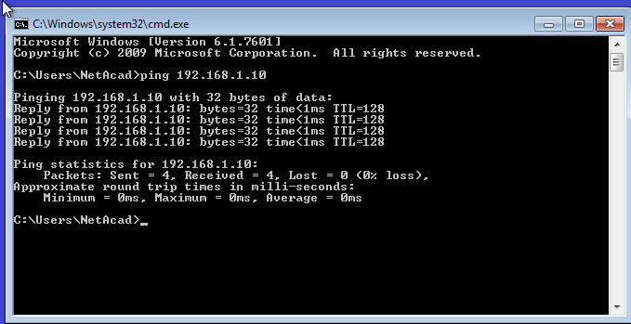

1. Ping the SVI management address of S1.

C:\Users\NetAcad> **ping 192.168.1.2**

Your output should be similar to the following screen. If ping results are not successful, troubleshoot the basic device configurations. You should check both the physical cabling and IP addressing, if necessary.

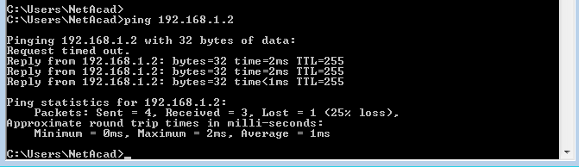

* 1. Test and verify remote management of S1.

You will now use Telnet to remotely access the switch S1 using the SVI management address. In this lab, PC-A and S1 reside side by side. In a production network, the switch could be in a wiring closet on the top floor while your management PC is located on the ground floor. Telnet is not a secure protocol. However, you will use it in this lab to test remote access. All information sent by Telnet, including passwords and commands, is sent across the session in plain text. In subsequent labs, you will use Secure Shell (SSH) to remotely access network devices.

**Note**: Windows 7 does not natively support Telnet. The administrator must enable this protocol. To install the Telnet client, open a command prompt window and type **pkgmgr /iu:“TelnetClient”**.

C:\Users\NetAcad> **pkgmgr /iu:”TelnetClient”**

1. With the command prompt window still open on PC-A, issue a Telnet command to connect to S1 via the SVI management address. The password is **cisco**.

C:\Users\NetAcad> **telnet 192.168.1.2**

Your output should be similar to the following screen:

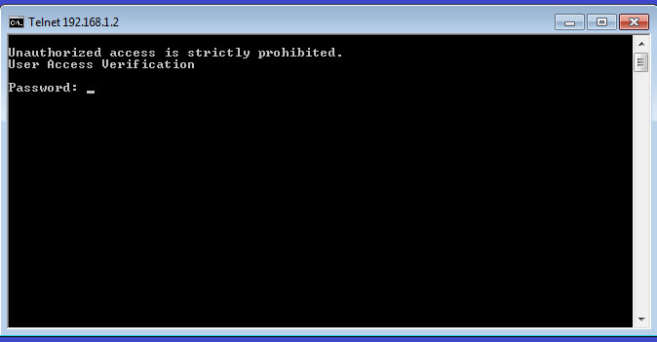

1. After entering the **cisco** password, you will be at the user EXEC mode prompt. Type **enable** at the prompt. Enter the **class** password to enter privileged EXEC mode and issue a **show run** command.
   1. Save the configuration file.
2. From your Telnet session, issue the **copy run start** command at the prompt.

S1# **copy run start**

Destination filename [startup-config]? **[Enter]**

Building configuration ..

S1#

1. Exit the Telnet session by typing **quit**. You will be returned to the Windows 7 command prompt.

Reflection

Why must you use a console connection to initially configure the switch? Why not connect to the switch via Telnet or SSH?

_______________________________________________________________________________________

No IP addressing parameters are configured yet. A switch first placed into service has no networking configured.

1. Device Configs
2. Switch S1(Complete)

S1#show run

Building configuration...

!

Current configuration : 1508 bytes

!

version 15.0

no service pad

service timestamps debug datetime msec

service timestamps log datetime msec

no service password-encryption

!

hostname S1

!

boot-start-marker

boot-end-marker

!

enable secret 4 06YFDUHH61wAE/kLkDq9BGho1QM5EnRtoyr8cHAUg.2

!

no aaa new-model

system mtu routing 1500

!

!

no ip domain-lookup

!

spanning-tree mode pvst

spanning-tree extend system-id

!

vlan internal allocation policy ascending

!

!

interface FastEthernet0/1

!

interface FastEthernet0/2

!

interface FastEthernet0/3

!

interface FastEthernet0/4

!

interface FastEthernet0/5

!

interface FastEthernet0/6

!

interface FastEthernet0/7

!

interface FastEthernet0/8

!

interface FastEthernet0/9

!

interface FastEthernet0/10

!

interface FastEthernet0/11

!

interface FastEthernet0/12

!

interface FastEthernet0/13

!

interface FastEthernet0/14

!

interface FastEthernet0/15

!

interface FastEthernet0/16

!

interface FastEthernet0/17

!

interface FastEthernet0/18

!

interface FastEthernet0/19

!

interface FastEthernet0/20

!

interface FastEthernet0/21

!

interface FastEthernet0/22

!

interface FastEthernet0/23

!

interface FastEthernet0/24

!

interface GigabitEthernet0/1

!

interface GigabitEthernet0/2

!

interface Vlan1

ip address 192.168.1.2 255.255.255.0

!

ip http server

ip http secure-server

!

banner motd ^C

Unauthorized access is strictly prohibited. ^C

!

line con 0

password cisco

login

line vty 0 4

password class

login

line vty 5 15

login

!

end